Client-Side Technologies (HTML/CSS/Ajax/JSON)

Thursday 28th November

**Instructions:**

Time allowed 1hr 50mins. Upload a .zip of the folder containing all your files to Moodle.

**NB**: For maximum marks keep HTML, CSS and JavaScript in separate files.

1. Use the file called index.html available on Moodle and create a .css file to give the following layout using information below.

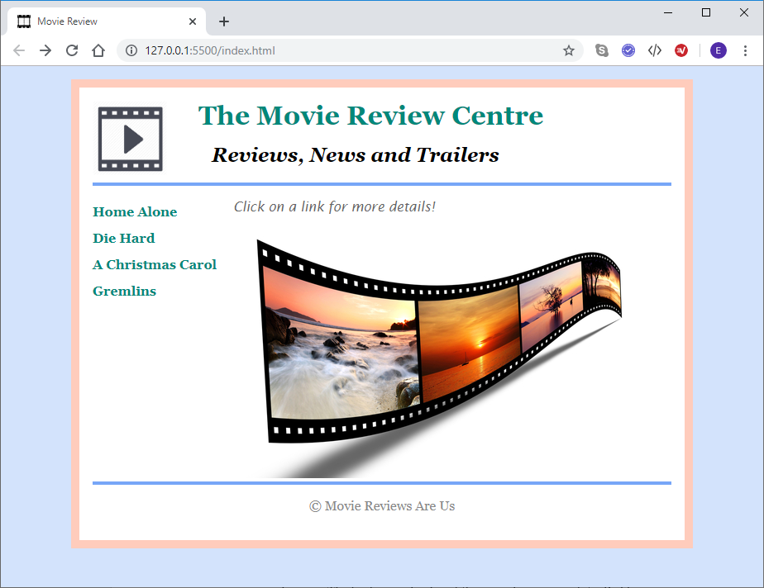

Aside

Header

Section

Footer

Note: You should float images and divisions as necessary to achieve the above layout.

1. The document uses the Georgia font-family or serif as default, and the background color is #D3E3FC.
2. The body width is 700 pixels. Use a margin with a value of auto left and right and 1em top and bottom. The background color of the body is white. Padding is 1em on all sides. The body also has a solid border of 10px with color #FFCCBC.
3. The header division has a 4px solid bottom-border of color #77A6F7.
4. The header division contains an image, a h1 and a h2 element. The h1 is color #00887A, it has a margin of 0 on the top and right, .5em on the bottom, and 4em on the left.
5. The header h2 should have the top margin set to 0, and the left margin set to 6em. Its font style is italic.
6. The aside should have a width of 170px and a height of 300px.
7. The links in the aside should have the underline removed (text-decoration), should be color #00887A and have the font weight set to bold.
8. The aside ul should have the dots removed (list-style-type), and the line-height should be 2. Set the left padding of the ul to 0.
9. The font color for the links should change to brown when the mouse moves over them. (hover).
10. The <p> in the ‘intro’ div has a font-family of ‘Lucida Sans’, font style of italic, color #666 and the bottom margin set to 0.
11. Images that are direct descendants of the ‘details’ div should have the right margin set to 2em. (#details > img)
12. The footer has a solid 4px top border of #77A6F7.
13. The copyright text is center aligned with color #888.
14. The film details for each file are stored as JSON files. (attributes: title, genre, running_time, image and rating). You need to write the JSON files.
15. When a link is clicked use ajax to fetch the details and display the film details in the details division as shown.

The following screenshots show how the page looks when each movie is chosen (clicked).

The heading is a <h3> and the other details are <p> elements.

**Home Alone:**

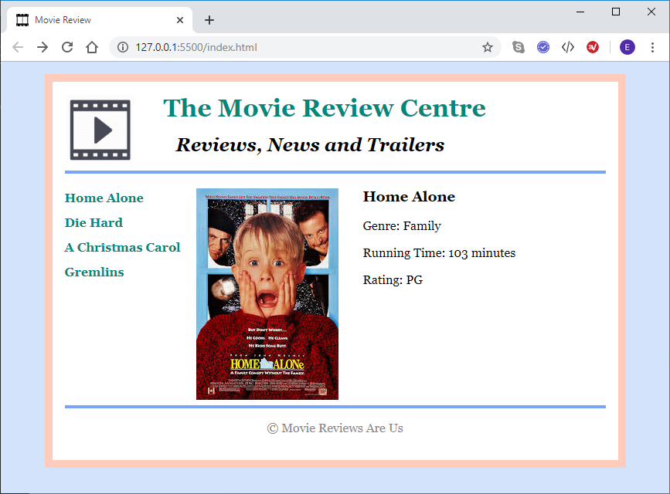

**Die Hard:**

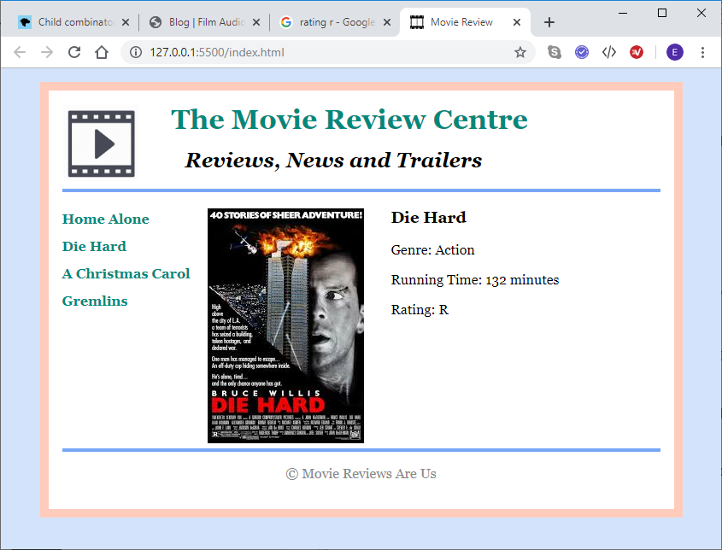

**A Christmas Carol:**

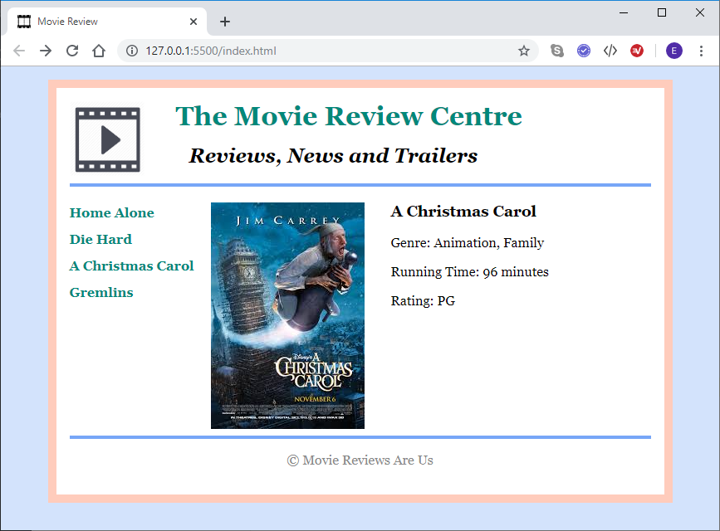

**Gremlins:**

